IT2120 - Probability and Statistics Lab Sheet 06

Exercise

1. 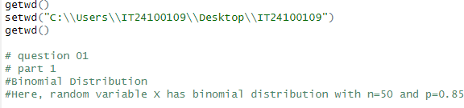i)

ii)

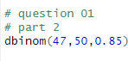

1. i)

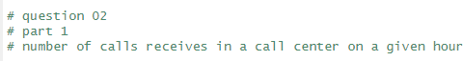

ii)

iii)

